Extra 6-1 Create a Reservation form

In this exercise, you’ll create a Reservation form like the one below. To make this easier, you’ll start from a web application that includes some of the aspx code for the form, plus Bootstrap and a custom style sheet to format it.

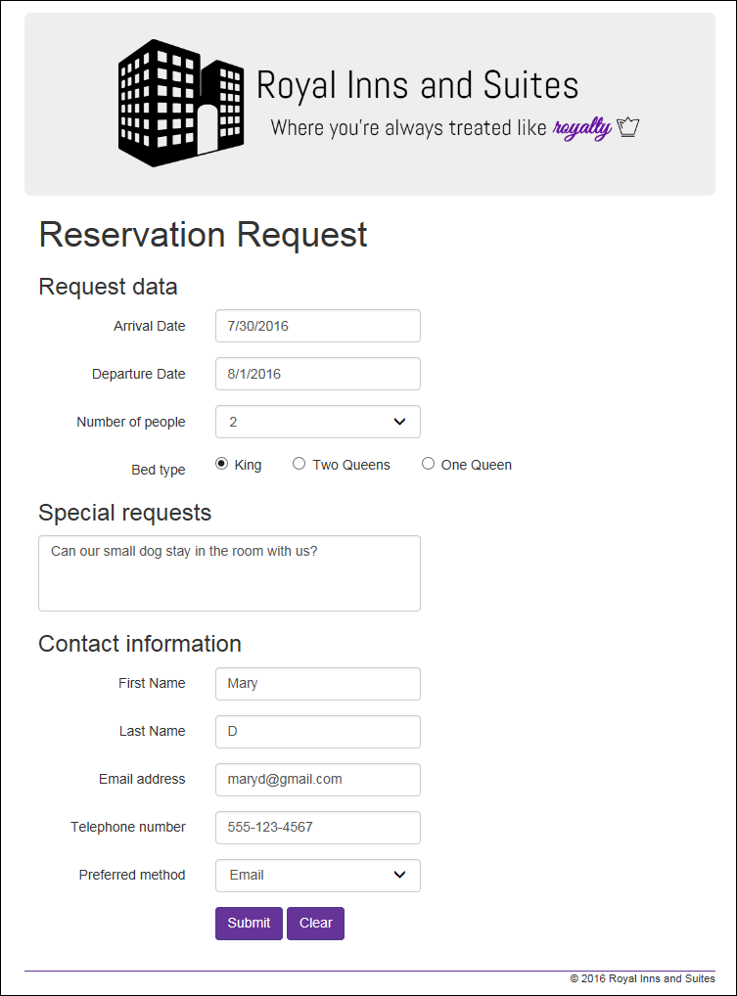

Open the web application and review the files

1. Open the XEx06Reservation web application in your exercises_extra directory.
2. Review the code in the Request.aspx web page and in the site.css style sheet in the Content folder. Note that this application overrides some of the default Bootstrap CSS classes. Then, set Request.aspx as the start page for the application.
3. Run the Request page to see how much work has been done for you. Notice that it includes the header, footer, headings, labels, text boxes for the arrival date and first name, and the buttons. So your job is to add the rest of the ASP.NET controls.

Add the controls for the form

1. Note that the control for the arrival date is just a text box. Then, add a text box for the departure date that’s like the one for the arrival date.
2. Add the drop-down list for the number of people, with choices of 1, 2, 3, and 4.
3. Add a radio button list or three radio button controls for bed type. Note that the div that will contain these controls has a “bedtype” class already assigned. This CSS class corrects for a display issue that can happen when you use radio button server controls with Bootstrap. You can review this class in the site.css file.
4. Add a multiline text box for special requests and set its Rows property to 4. Remember that a multiline text box is rendered into an HTML textarea element.
5. Add the text boxes for the last name, email address, and telephone number entries.
6. Add the drop-down list for the preferred contact method with two options: Email and Telephone.

Finish the aspx code for the form

1. Set the CssClass properties for the text boxes and drop-down lists to form-control. Make sure to include the multiline text box.
2. Add TextMode attributes to the text box controls that they apply to (see figure 6-4).
3. Test the form to make sure that it looks right, and make any adjustments.

Add the C# code for the form

1. Code a Load event handler to set some starting values for the form. You’ll use the private variables at the top of the page for this. Specifically, use the currentDate variable to set the arrival date and the currentYear variable to set the year for the copyright statement in the footer. Finally, set the checked attribute of the King radio button to true.
2. Code an event handler for the Click event of the Submit button that displays this message in the label that’s below the buttons:

Thank you for your request.  
We will get back to you within 24 hours.

1. Code an event handler for the Click event of the Clear button that returns all of the control values to their defaults. If you used individual radio buttons for the bed type, you may need to turn the checked attribute off for the Two Queens and One Queen options as well as turning the checked attribute for the King option on. Also, you can use the currentDate variable at the top of the page to re-set the arrival date.
2. Run the application, check that all of the controls work right, and make any corrections.